Chapter 19, Solution 7.

Calculate the impedance-parameter equivalent of the circuit in Fig. 19.71.

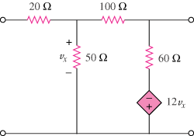

Figure 19.71
For Prob. 19.7.

Solution

To get z₁₁ and z₂₁, we consider the circuit below.
I₂=0
I₁ 20 100

+ + + v_{x} 50 60
V₁
- V₂
- -
12v_{x} -

+

To get z₁₂ and z₂₂, we consider the circuit below.

I₂
I₁=0 20 100

+ + + v_{x} 50 60
V₁
- V₂
- -
12v_{x} -

+

Thus,

